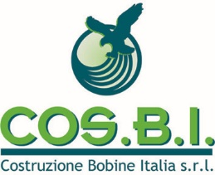

ENVIRONMENTAL POLICY

COS.B.I. srl is committed to prevent pollution, to ensure the preservation and protection of the environment and to continually improve its environmental performance while minimizing the risks associated with the activities carried out and/or with products and service provided.
In accordance with these agreements, COS.B.I. aims to achieve the following objectives:
- Comply with the existing legislation on the significant environmental impact of the company;
- Eliminate risks to safety of people and protection of the environment, in relation to the knowledge acquired and, where this is not possible, try to minimize them, possibly acting on the causes that produced them;
- Adopt a plan for prevention and management of the environmental emergencies;
- Carry out a continuous control of the production process and monitor all related environmental aspects/impacts;
- Promote awareness about the environmental policy contents among suppliers of goods and services;
- Communicate in a transparent manner our own environmental perfomance in order to gain and build confidence regarding the activities and products/services provided;
- Rationalize the use of natural and energy resources;
- Commit to managing waste so as to favour, where possible, recovery and recycling rather than disposal.

The Direction sets specific targets, in the short and medium term, that are announced and shared at all levels of the organization when the Direction perfoms the review.

CO.S.B.I. is committed to providing the technical, financial and professional resources necessary for environmental policy objectives, as defined in this document, to be fully met.
The present Environmental Policy is disseminated to all levels and it is everyone’s task to collaborate actively, in so far as they are concerned, in order to improve the Environmental Management System.
COS.B.I. guarantees, through subsequent monitoring activities, that this policy is included and implemented and the goals declared are pursued.

